Delivery of Sprint – 4

|  |  |
| --- | --- |
| **Date** | **November 16 2022** |
| **Team ID** | **PNT2022TMID34757** |
| **Project Name** | **Smart Waste Management for Metropolitan Cities** |

1. Node-RED Connection setup for data transmission from IBM Watson IOT platform to Node-RED dashboard.

77

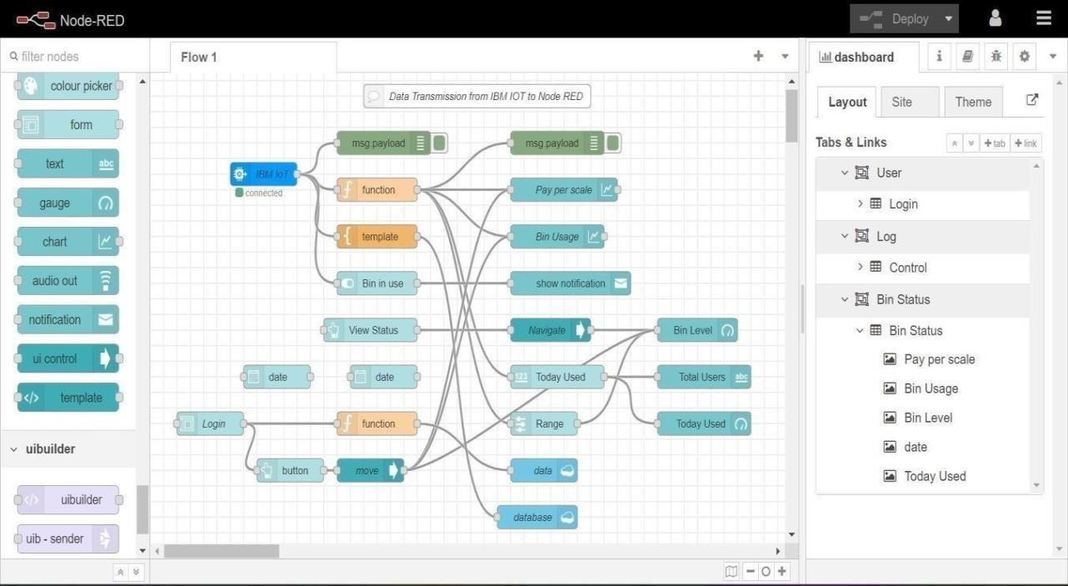

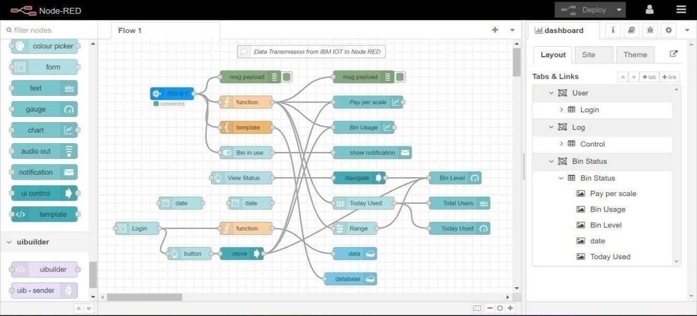

1. Simulate Wokwi connection to transmit data from wokwi account to IBM Watson IOT platform and then to Node Red dashboard.

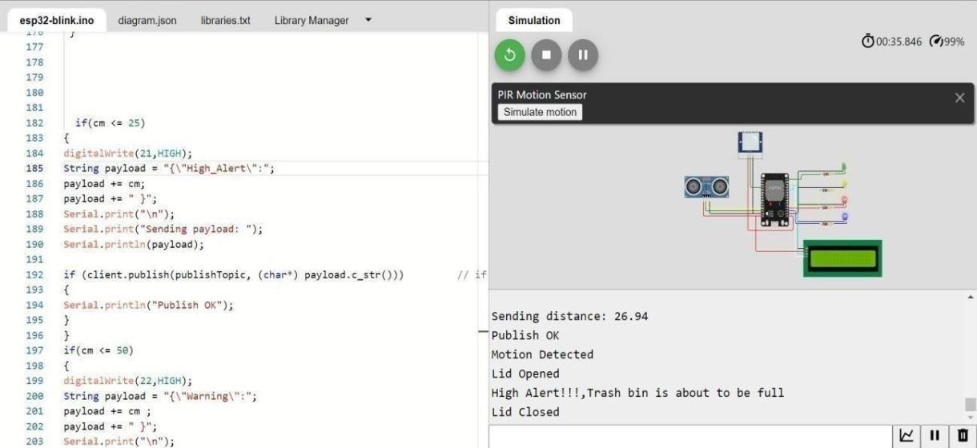

1. Data transfer to Watson IOT platform.

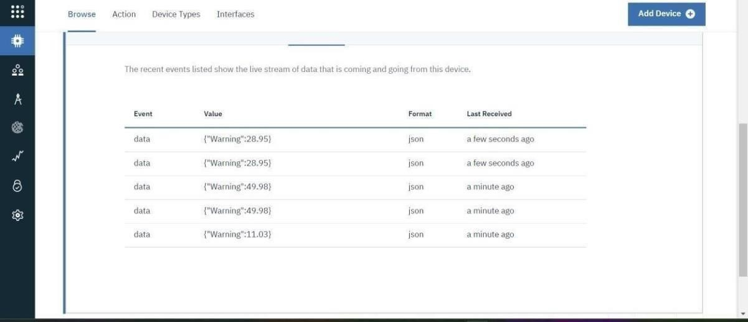

1. Data transfer from IBM Watson IOT platform and wokwi to Node red.

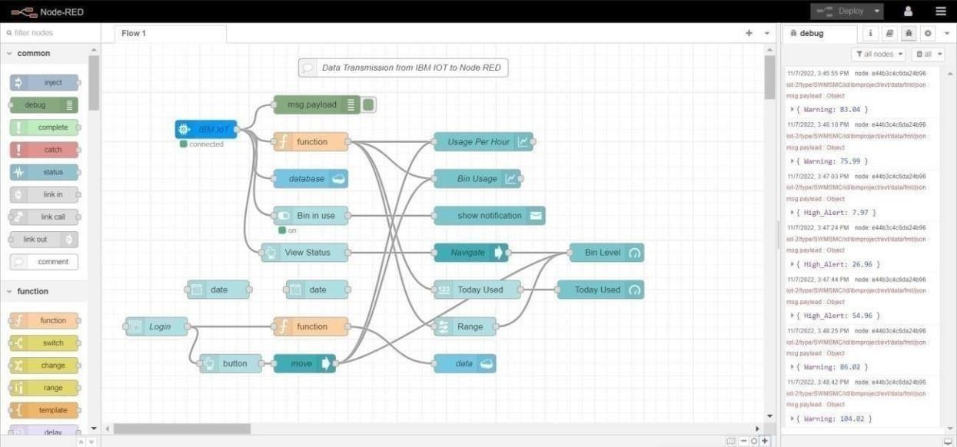

5 . Storing database in IBM cloudant DB.

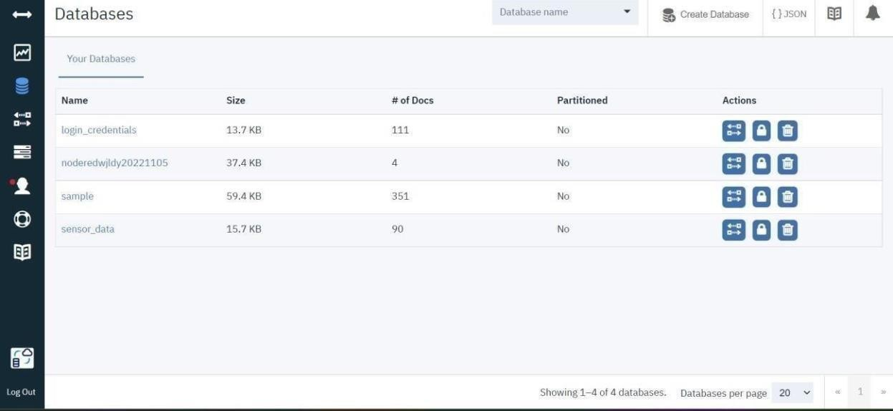

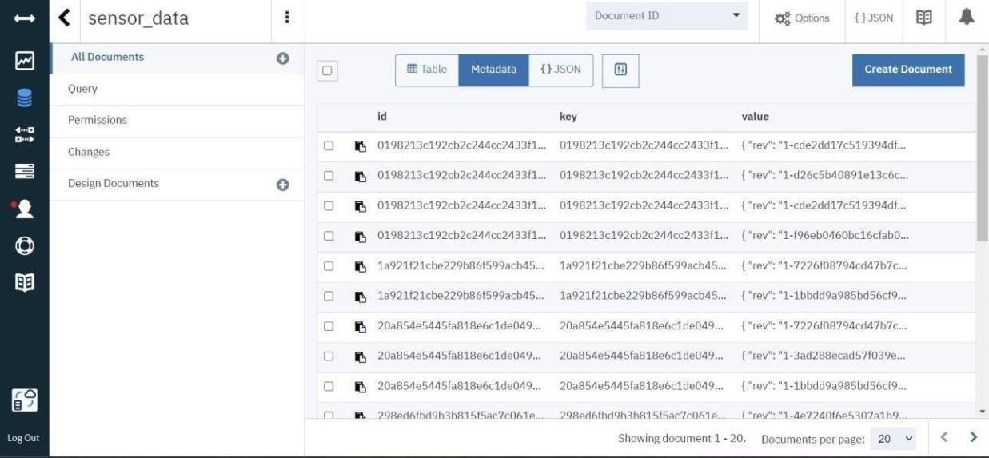

1. 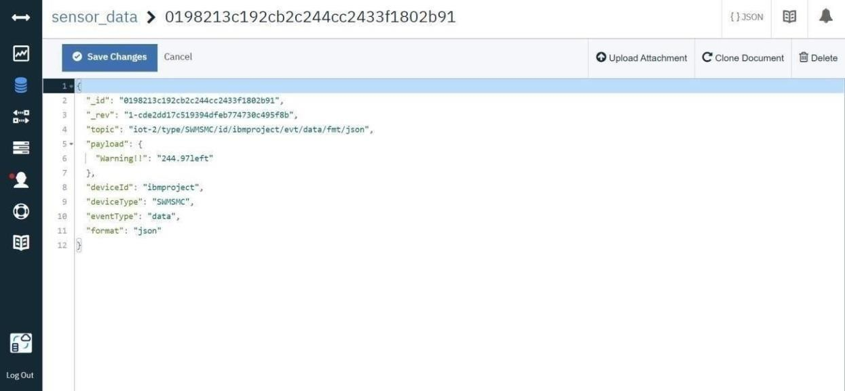Data is stored in JSON format
2. Web UI

